Teacher: _________
2023-24 AP Exam Commitment Form
Advanced Placement Students and Parents,

Congratulations for enrolling in at least one Advanced Placement (AP) course this year. You join high school students around the world that take AP courses and exams to challenge themselves, explore their interests, and earn college credit and placement.

The College Board has provided resources to support students to be successful in AP and earn college
Credit.
- Schools will continue to order the exams in the fall, and testing will occur in May 2024.
- Students will get personalized feedback through digital tools that provide daily support for every AP classroom. Teachers can track student performance throughout the year using an online bank of real AP practice questions and monthly personal progress checks. These online resources encourage students to commit to the exams early and stay engaged throughout the year, increasing their chances of earning college credit.

The North Carolina Department of Public Instruction (NCDPI) has appropriated funds to pay for AP exams for students who are enrolled in the corresponding AP course and who do not qualify for need-based assistance (see the back of this form for criteria). Homeschool students, private school students and CMS students NOT enrolled in an AP class, but wish to take an AP exam must pay $98 for each exam and $145 for AP Capstone (research and seminar) exams. However, if the student qualifies as need-based (see the back of this form for criteria) and submits the completed waiver on the back of this form, the student will receive a discounted rate of $64 per AP exam ($110 for AP Capstone exams).

All students enrolled in AP classes are required to take the corresponding AP exam offered by the College
Board per the CMS Board of Education Policy IKAA-R. Specific to AP, the policy states that:
- A student enrolled in an AP course must take the AP examination offered by the College Board for the particular course in which the student is enrolled. A student who does not take the required AP examination must take a teacher provided comprehensive examination for the course.
- A student’s grade on the teacher-provided comprehensive examination shall count as 20% of the student’s final course grade. As provided in Regulation IKA-R, grades in AP courses for students who take the corresponding AP exam will be calculated according to the formula: Semester 1 (50.00%) + Semester 2 (50.00%) = final grade.

Students and parents, we ask that you complete the form below and the need-based waiver on the back of this page (if applicable) to show your commitment to the new AP platform and exam requirements. Please return to your AP teacher NO LATER THAN FRIDAY, November 10, 2023.

PLEASE PRINT AND COMPLETE THE INFORMATION BELOW.

Student Name:____________________________________
Student ID#: ______________ School Name: ____________________________

Parent/Guardian Signature: ___________________________________________________________________

Student Signature: ______________________________________________________________________________

Turn over to complete the AP Need-Based Assistance Waiver (all students complete form)

Student Name: __________________________________________

Students who have been approved for free or reduced-price meals through Charlotte-Mecklenburg Schools Child Nutrition Services or families who meet one of the criteria listed below will qualify for grant funding to cover either all or partial costs of the AP exam(s). In order to maximize possible reimbursements of exam fees, it is requested that families eligible based on the criteria listed below complete and return this form to the school testing coordinator no later than Friday, October 26, 2023. If the information below does not apply to your household, disregard this side of the form. Information on this form will not be shared with any other entity or program.
Please complete if your child QUALIFIES for a fee-based waiver(non-fee waiver eligible testers complete below)
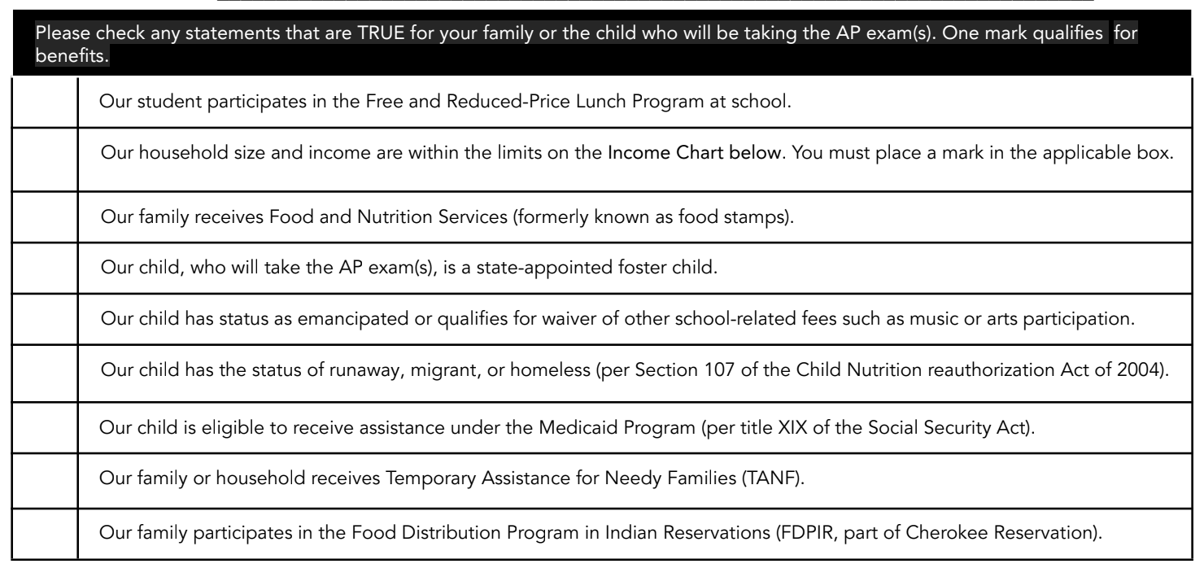
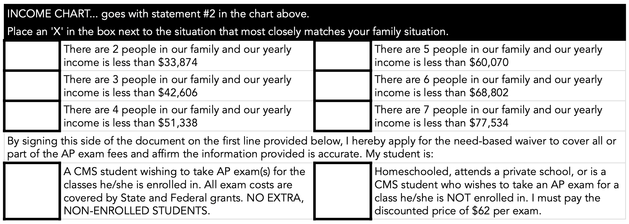
Please complete if your child DOES NOT QUALIFY for a fee-based waiver but is taking AP exam(s):
☐ Our child/family does NOT qualify for a needs-based waiver but is enrolled in the class with
CMS/NCVPS.
☐ Our child/family does NOT qualify for a needs-based waiver and is NOT enrolled in the class with
CMS/NCVPS. We understand we have to pay the AP exam fees associated with the test/course.
☐ Our child/family does not qualify for a needs-based waiver and is NOT a CMS/NCVPS student..

__________________________________________________________________________________________________
Parent/Guardian Signature Date

